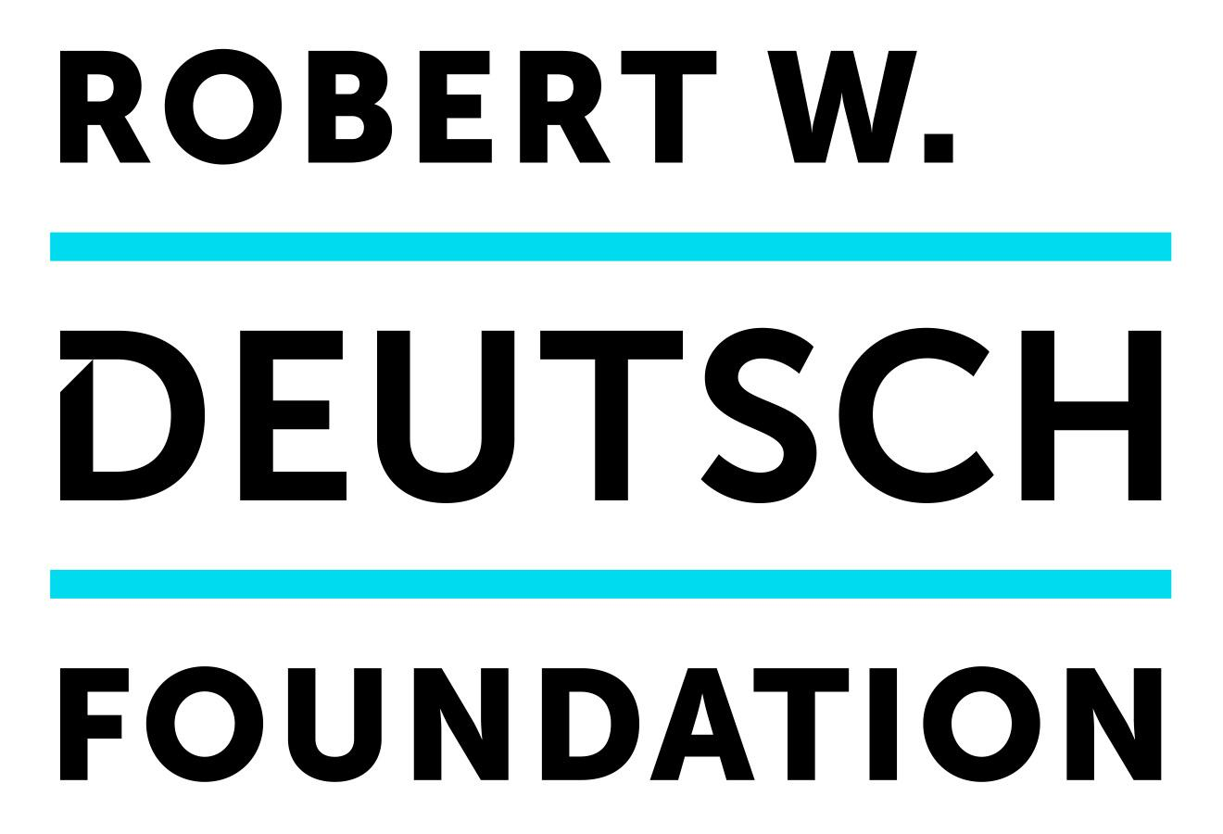 |  | Rubys Artist Project Grant  2024 Grant Guidelines

Online application portal opens: February 27, 2024
Deadline to apply: March 28, 2024
Apply at: https://thedeutschfoundation.submittable.com/

INTRODUCTION
The Rubys were established in 2013 to provide project-based support for individual artists. The goal of the program is to provide meaningful support to individual artists to allow for the creation of new work. The Rubys supports the notion of risk-taking (in practice, content, process, and/or outcome) and equally values artistic integrity, strong ideas, feasibility, and communal meaning. The program is open to artists at any stage of their career and favors projects that have significant creative work left to accomplish.

Grants will enable individual artists to create or complete a project that will include a public component occurring at some point during the grant period. The public component may be a performance, presentation/lecture, screening, exhibition, reading, or any other type of event that fits with the nature of the project.

REGULAR GRANT OVERVIEW
Artists may apply for grants of up to $15,000 to be applied to a project over a 12-month period. Artists may submit only one application during each funding round. Grants may be used to support projects that are already in process, a project not yet begun, or a distinct phase of a longer-term project. Preference is given to projects that have significant creative work left to be done.
ALUMNI GRANT OVERVIEW
Artists may apply for a grant of up to $25,000 to be applied to a project over a 12-month period. Artists may submit only one application during each funding round. Grants may be used to support projects that are already in process, a project not yet begun, or a distinct phase of a longer-term project. Preference is given to projects that have significant creative work left to be done. Artists who apply to the Alumni Grant will be juried in one pool of all four disciplines together, juried by a cross-section of jurors for the regular grant pool. Only one award will be granted across all four creative disciplines in the Alumni category each year. This grant is very competitive.

ARTISTIC CATEGORIES
For the first time, ALL ARTISTIC CATEGORIES are represented in the grant cycle. Moving forward, there will be only one grant cycle per year. Artists may submit one application per year. Previous recipients of the Rubys as individuals or consistent collaborators may only apply to the Alumni Grant.

Literary Arts includes but is not limited to: nonfiction; fiction; poetry; graphic novels; cross-disciplinary; experimental/emerging fields.

Media Arts includes but is not limited to: film; audio and video projects; animation; computer graphics; sound art; digital arts; screenplay; teleplay; cross-disciplinary; experimental/emerging fields.

Performing Arts includes but is not limited to: dance; music; theater; musical theater; opera; puppetry; performance art; playwriting; spoken word; storytelling; traditional/folk art; cross‐disciplinary; experimental/emerging fields.

Visual Arts includes but is not limited to: painting; photography; sculpture; works on paper; craft; installation; traditional/folk art; cross-disciplinary; experimental/emerging fields.

ALUMNI GRANTS: Include artists who have received a Ruby award as an individual artist or with their consistent collaborator. If the same creative collaborators are applying for new project funding, it should go through the alumni grant process. If, however, a single member of a collaborative group that previously received the award is applying for a project in their own, solo, practice, they may apply to the regular grant pool in their artistic category.

ELIGIBILITY
To be eligible for a regular Rubys grant, an artist must:
- Be a resident of Baltimore City, or Baltimore County at the time that grant is awarded.
- Have a valid U.S. tax identification number
- Be at least 21 years old
- Be a practicing artist: Those who have actively and continually pursued their profession in this discipline for more than three years (as evidenced on your resume with application)
***Rubys Alumni Grant Applicants may reside anywhere, but MUST be willing to work with the cohort of new rubys in their creative discipline as a mentor, conducting studio visits and critical conversations, and to present an artist talk to the Rubys cohort and broader community during the one year grant period.***

The following are not eligible for grants from this program:
- Organizations
- Full-time or part-time students in a degree-earning program
- A current board member, committee member, staff, or consultant for the Robert W. Deutsch Foundation, or their immediate family members

The Rubys provide grants to support your own artwork/creative project

Examples of eligible projects  - Creation of a new body of paintings  - Supporting the production phase of your film  - Completing the writing of the first draft of a novel  - Finishing the writing of a play and staging a reading | Examples of ineligible projects  - Curating an exhibition featuring other artists’ works  - Supporting the publication costs of a completed novel  - Producing a music festival  - Supporting a workshop that teaches art to others  - Editing an anthology of other writers’ works

SELECTION CRITERIA
Round 1:
- Creativity of the project, in that it is an innovative step for the artist, or that it is a significant deepening of their current artistic practice, or that it will be a meaningful contribution to the arts community.
- Dedication to your creative practice, documented in your Artist Resume / CV
Round 2:
- Artistic merit and skill of the work represented in the work samples
- Feasibility of the project, including likelihood that the project can be realized, based on the budget, timeline, and proposed logistics and details.

SELECTION PROCESS
A review panel of creative professionals will be convened for each discipline to select the grant recipients. The panel will be composed of artists and arts professionals, both from the region and nationally.

HOW TO APPLY
The grant application must be submitted online at: https://thedeutschfoundation.submittable.com/

Applicants may log in and log out of the application platform (Submittable) as much as needed during the application period. However, all materials must be finalized and submitted by the deadline.

REQUIRED APPLICATION MATERIALS
The regular application includes the following elements:
Round 1
- Project Title
- Short Project Description
- Resume/CV
- Consideration of audience and context
Round 2:
1. Full Project Narrative
2.Project Budget
3. Project Timeline
4. Work Sample Inventory
5. Work Samples

Alumni will be asked the same questions, but they will also have to answer how this new project builds on their previously supported work, and propose a style of mentorship and timeline for their artist talk.

ROUND 1:
Round 1 consists of short answers:
-Project Title and one-line description
-Short Project Description

Questions:
1. What kind of impact (artistic, social, political, intellectual, civic, etc.) do you hope your project will have? What strategies will you employ to achieve the desired impact? (120 words)
2. Who are the specific audiences and/or communities that you hope to engage with this project? Please think beyond the broader art communities where possible. What strategies will you employ to reach them? (120 words)
3. How will your proposed project act as a catalyst in your professional growth? Why is this a pivotal point in your practice? (120 words)
4. How does this project demonstrate personal innovation or an imaginative take on the content and form? * (150 words)
*Consider this within the context of your own work, how is this project something new for you and your practice?

Attachments:
Resume/CV: 2 pages maximum (per artist*)
Your resume should include information of past presentations of your artwork (exhibitions, screenings, performances, readings, etc…), including any awards, recognition, or publication mentions you have received as an artist.
*may submit a single pdf document with each collaborator’s cv included – each artist should use a maximum of 2 pages for their curated CV.

ROUND 2
1. Full Project Narrative: One page maximum
Include your name and project title at the top of the Project Description, so that it appears as such:
Mary Smith
Project: The Story of My Life

Organize your narrative using the following points as your guide:
- Introduce yourself as an artist: Briefly describe your creative mission, the current state of your practice, and your perceived place in the local arts community. (10%)
- Describe the proposed project. Provide as much information as is currently known describing the creative and logistical elements of the project. (75%)
  - What is the inspiration or storyline of your project?
  - Describe the artistic process for this project.
  - What is the final goal, outcome, or milestone at the end of the grant period?
  - How will the audience/viewer experience your art?
- Propose how your project would be publicly shown. Include the names of venues/partners, if relevant, of who you would reach out to in order to facilitate the public presentation. (10%)
  - Any sort of public-facing event, large or small, may be proposed (a performance, screening, exhibition, open studio, tour, reading, or something else). Ensure that your proposal makes sense and is feasible for the project you intend to do.
  - You need not have any plans/venues/contracts confirmed at the time of application.
- Explain why this is the right time in your career for this project to come to fruition. (5%)

2. Project Budget: One page maximum
Please prepare a complete budget that includes all costs and income for your project, even those line items above and beyond your grant request. Applications with incomplete or unbalanced budgets may be disqualified. You are not required to provide matching funds for the Rubys grant if the grant can fully cover your project expenses.

Allowable expenses include:  - Your fee as an artist (to support your time)  - Fees to collaborators including other artists and vendors  - Project-related travel and materials  - Equipment for the project  - Space rental  - Promotion and marketing  - Artist overhead | Unallowable expenses include:  - Personal debt repayments
Additional project income can include:
- Funds from government agencies, foundations, businesses, individuals
- Your own money
- In-kind materials, services

3. Project Timeline: One page maximum
Please prepare a timeline and identify key dates for your project. If the project timeline is longer than the 12-month grant period, identify the phase for which the Rubys grant will fund. Note the public component that will occur within the grant period. The timeline for this grant cycle is approximately July 2024 to June 2025. If this is part of a larger project, please outline the one year phase that the Rubys will support within the larger project timeline.

4. Work Sample Inventory List: One page maximum
Prepare an inventory list of the work samples that you will upload to accompany your application. Ensure that the titles on the inventory list match the titles of the uploaded work samples.

The Project Description, Budget, Timeline, Resume/CV, and Work Sample Inventory List must be bundled together into one document and uploaded as such. Word or PDF format.

5. Work Samples: 10 files maximum allowed
Applications should have a minimum of one, and are allowed a maximum of ten, work samples to accompany their project proposal.
One work sample should directly relate to the proposed project. The sample can be a draft (for example: Script/book synopsis, storyboard, installation layout, draft drawings, thematic outline). Other work samples may be of past work that demonstrates the applicant’s skill set and creativity.

Applicants are allowed to mix-and-match their work samples among the following file formats:
- Document (PDF or Word): 25 pages maximum across all document files
- Video (MP4 or MOV): 3 minutes maximum per video file
- Audio (MP3 or WAV): 3 minutes maximum per file
- Image (JPG)

Individual file size has a limit of 400 MB.

For audio and video files, please edit the file to the clip you would like the jury to hear/view.

The jury panel is only required to view those samples uploaded to your application. While you may include links to external sites on your resume or inventory list, the jury is not required to go to those sites. Do not simply list a web address as a work sample.
QUESTIONS
Contact the Foundation if you:
- Have questions about application requirements and general submission policies, including what category to apply in, deadlines, or other administration issues
- Have questions about the grant review process, status, or results
- Need to edit an application you already submitted

Contact: Alex Ebstein, Program Director
Or
Barbara Eucebio, Arts Program Coordinator
rubys@rwdfoundation.org
443-275-1144

Contact Submittable if you:
- Have questions regarding technical issues with the online submission process
- Have questions regarding formatting your files, or encounter errors while uploading

Contact: Submittable Customer Support
855-467-8264
support@submittable.com

